Module 2 - Selecting Appropriate Assessments

Slide 1 | 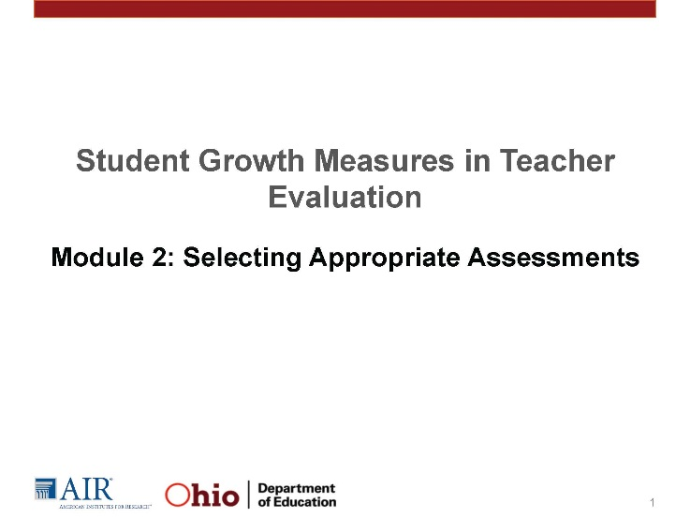
Slide 4
In Module 1, we touched on the first four steps of the SLO development process. In Modules 2 and 3, we will dive more deeply into Step 3 of the development process: choose assessments and set the growth targets.
Slide 5  Ohio guidance documents rank assessment types based on the likelihood that assessments will be aligned to standards, and are rigorous, valid, and reliable. Teachers must use state assessments wherever possible. The next highest ranked assessments are commercially available assessments | 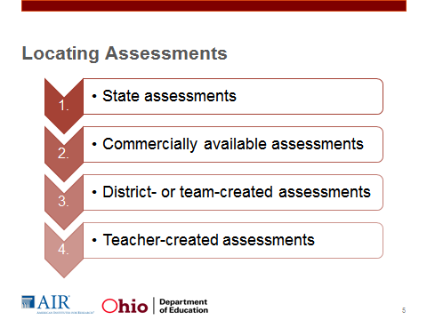
Slide 6  ODE’s ranking of assessments can be a helpful starting place.  Look at Handout 2.1, the Checklist for Selecting Appropriate Assessments. This document, included in a larger guidance document on the ODE website, is divided into three major parts: alignment, stretch, and validity and reliability. The checklist can be a useful tool for teachers and evaluators when selecting and evaluating assessments for use in the SLO. | 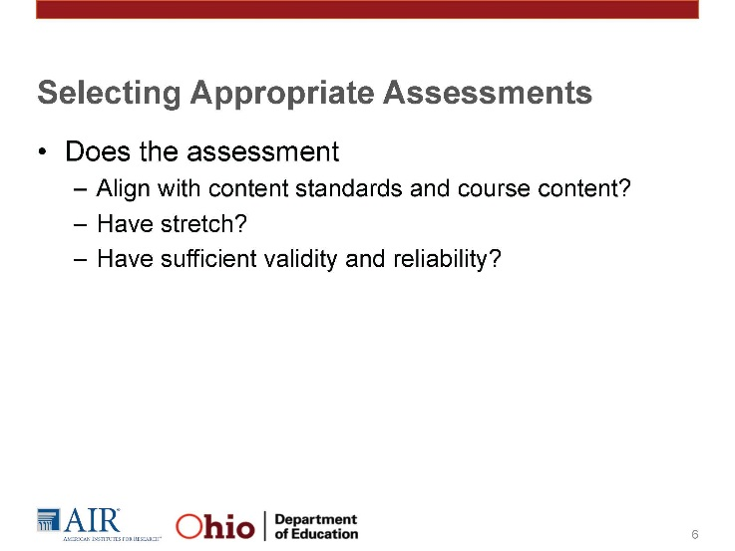
Slide 7  First, the measures used to gather baseline data and measure student growth should be aligned to state standards and course content. This means that the assessment should align with the content and skills of the content standards and the curriculum taught during the interval of instruction. | 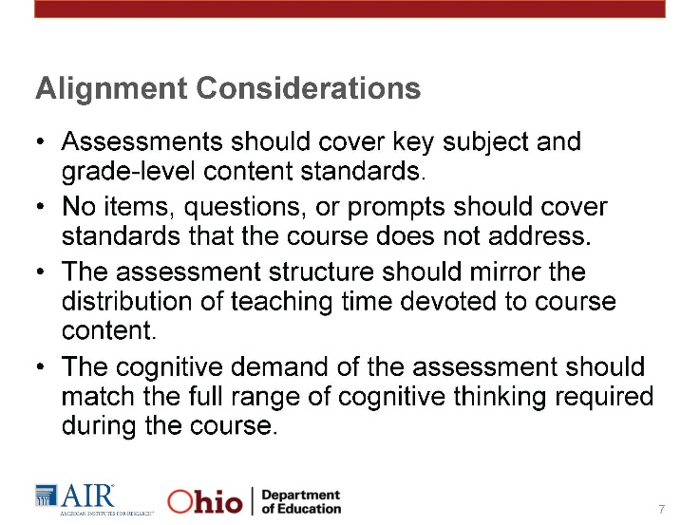
Slide 8 – Example  The social studies seventh-grade curriculum covers relevant world developments from 750 B.C. to A.D. 1600. By the end of the course, students should also be able to collect, organize, evaluate, and synthesize information from multiple sources to draw logical conclusions as well as communicate this information.  A teacher examined an available district-created assessment for potential use with the corresponding SLO. The assessment features 50 questions, 20 of which are focused on Ancient Greece and 20 of which are focused on Ancient Rome. Is this assessment sufficiently aligned with the content and the skills of the course?”  - The assessment is not aligned with the course.  - The multiple-choice questions focus on only Ancient Greece and Rome, omitting key societal developments. The content of this test may be more appropriate for a unit test but not as a test used in an SLO. The scope of the assessment is too narrow.  - The test overemphasizes multiple-choice questions. Instead, it should have a balance of question types, including a writing prompt or a performance task that will enable students to demonstrate their ability to collect, organize, evaluate, and synthesize information and then communicate it in a coherent, grade-appropriate way. | 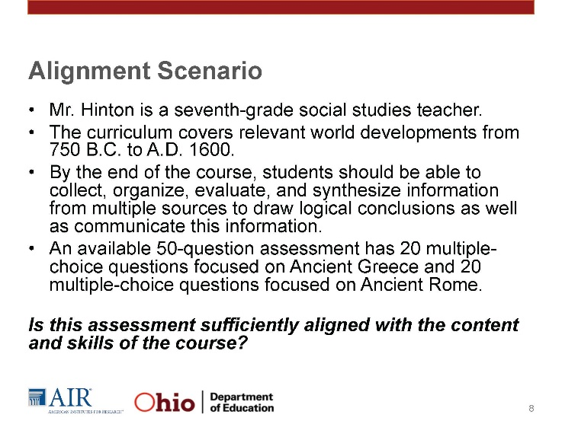
Slide 9  For students to demonstrate their learning, the assessment must allow both low- and high-achieving students to adequately demonstrate growth. The assessment should not be so advanced that teachers cannot get an accurate sense of what the lowest performing students know and do not know, but we also want to make sure that the assessment will also challenge the highest performing students. In some cases, teachers may need to use an extension assessment to ensure that the highest performing students are able to demonstrate growth. These extension assignments may be a portfolio of advanced work, a capstone project, or extension test questions. | 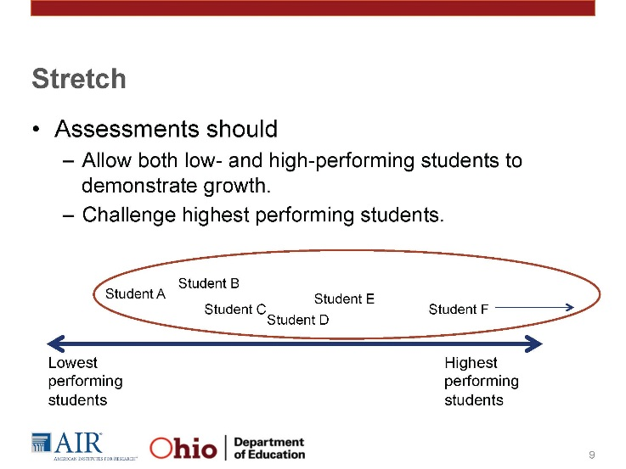
Slide 10 - Example  Ms. Simpson teaches second-grade reading. Most of her students are reading on-grade level, but the reading skills of one of her students are behind those of her peers. Three students are reading above by one grade level.  When creating her SLO, Ms. Simpson selected an assessment that covered all the reading standards for informational text and literature for second grade. In addition, some questions cover first - and third-grade expectations for reading. For example, one question asks students to distinguish their own point of view from that of the author; this is a first-grade expectation of students. Another question asks students to analyze multiple accounts of the same event or topic and note differences in points of view; this is a third-grade expectation of students.” Does this alignment have enough stretch? Why or why not?  The key points are as follows:  - Yes, the assessment has sufficient stretch.  - The assessment isn’t so low that we won’t be able to capture the starting point of the lowest performing student(s).  - The assessment contains questions that should sufficiently challenge the highest performing students. | 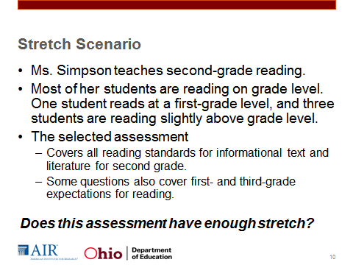
Slide 11  Finally, assessments must be valid and reliable. The assessment should measure what it says it measures and produce consistent results. When evaluating assessments for validity and reliability, teachers and teacher teams should consider the following:  - Directions and questions should be written clearly and concisely. Unless the assessment aims to test reading skills, the assessment should avoid overly complex vocabulary to ensure that it is assessing the appropriate skills and content. For example, a math word problem with overly complex names and vocabulary may not be an accurate indicator if students cannot apply their mathematical knowledge in a problem-solving situation.  - In addition, assessments should include procedures that will ensure consistency. This includes ensuring clear and consistent testing conditions, instructions, test items (if using different forms of a test across classes), and rubrics for performance-based assessments.” | 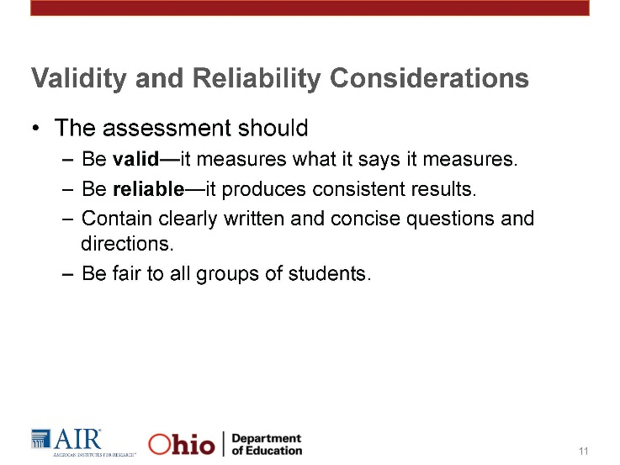
Slide 13  Questions that you can ask, either of yourself or others, to help ensure that an assessment is appropriate? | 